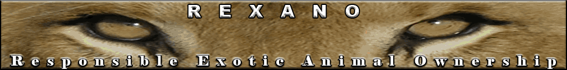
2007 Animal Rights, AR, Sponsored Exotic Animal Legislation Coinciding With Suspicious Exotic Animal Sightings and Dumping

STATES | INDIANA | N. CAROLINA | OHIO | OREGON
LEGISLATION INTRODUCED | 1/18/2007 | 3/22/2007  4/18/2007 | 2/20/2007 | 3/13/2007 First reading
BILL NUMBER | SB 482 | SB 1477  HB 1614 | HB 45 | Emergency Bill HB 3437
SUSPICIOUS INCIDENTS | Dead alligator dumped illegally with other trash on the street in Gary, 1/20/2007 | Cape Fear Serpentarium in Wilmington, received a phone call about an anaconda supposedly eating a pet dog,  January 2007 | Frozen snake found near bike path in Middletown, 1/30/2007 | Dead alligator found by the creek in Melrose, 3/19/2007
 | 3 feet long live baby alligator was found in a trailer park in Gary, 3/21/2007 | Days before the July 3rd hearing on SB 1477, news announced reptiles might be removed from these bills. This coincided with the suspicious report of a 'homeless' 5 pound baby alligator walking thru Charlotte.  6/29/2007 | Anonymous call, unconfirmed report of an alligator in a pond in Vandalia, 3/24/2007
 |  | It was not voted on 7/3/2007. Another baby alligator was found next day 40 miles from Charlotte 7/4/2007 | Dead alligator found with jaws shut at Grand Lake, one hour from Vandalia on 4/5/2007

www.REXANO.org Copyright © REXANO 2008

